**BALDIVIS SECONDARY COLLEGE**

** Methods Units 1 and 2**

**2020 - Investigation 1**

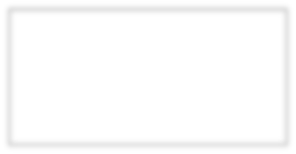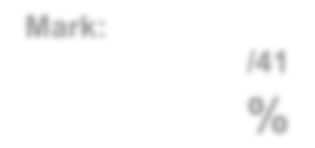

**Mark:**

**/30**

**%**

Student Name _____________________________________________

**Time allowed for this task:** Handout – Friday 3 April 2020 (Week 9 Term 1)

Due – Friday 8 May 2020 (Week 2 Term 2)

**Materials required:** **Take-home section** (30 marks)

Standard writing equipment

SCSA Formula Sheet

**Other materials allowed:** Drawing templates

**Marks available:** **30 marks**

**Task Weighting: 4%**

**\*NB. This is NOT a small task that can be completed in under 2 hours. Do not leave this assessment to the last minute. As all of the assessment can be completed at home, and you have been given 5 weeks to complete and submit, Senior School Assessment policy will be rigorously applied. Any extensions MUST be received a minimum of 7 days prior to the deadline with a valid reason.**

**The marking rubric will not be provided until all tasks have been submitted, however, you may refer to the grade descriptions provided in the SCSA Syllabus document on pages 17 - 19 (a hard copy was provided at the beginning of term and a further copy can be located on Connect in Content: Course Outline).**

**Task 1: [15 marks]**

Make a picture using the DESMOS online calculator which incorporates linear and quadratic equations, circles and any other functions that you have learned about or researched. You will need to use domain and range restrictions to get the desired effect. That’s it. You may combine your maths skills and your creativity to produce any picture that you want. It can be very simple or very complicated, it’s up to you.

Some information to help you:

* To save your file and graph you will need to create an account on Desmos. Please use your student email for this so that your privacy can be maintained.
* You can share the graph with me by using the share symbol  on the top right-hand side of the screen. You will then need to share the link with me via email (this way I have access to all of your equations). Please also export the graph, save it with your name and submit online via the submissions folder on Connect. This will log when you submitted the assessment and I will know to look out for your link to the equations.
* While you are welcome to look for ideas online, ALL work must be original.
* Try using folders and notes in Desmos to organise your ideas. This will help you to keep track of which equations did what. Clicking on the graph will also highlight the relevant equation. If you make a mistake you can ‘undo’ by using ‘Ctrl z’.

Some ideas of what is possible:

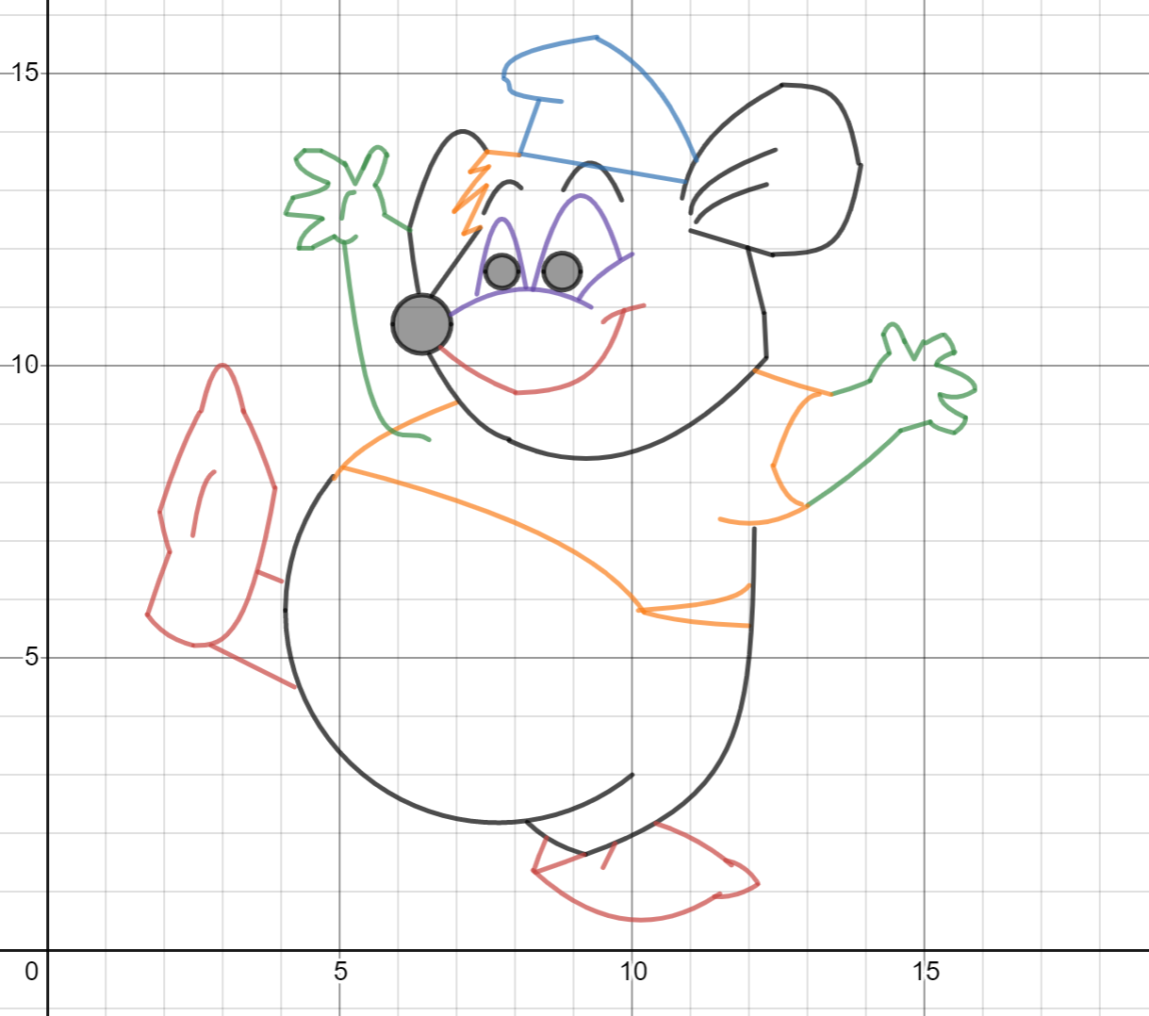 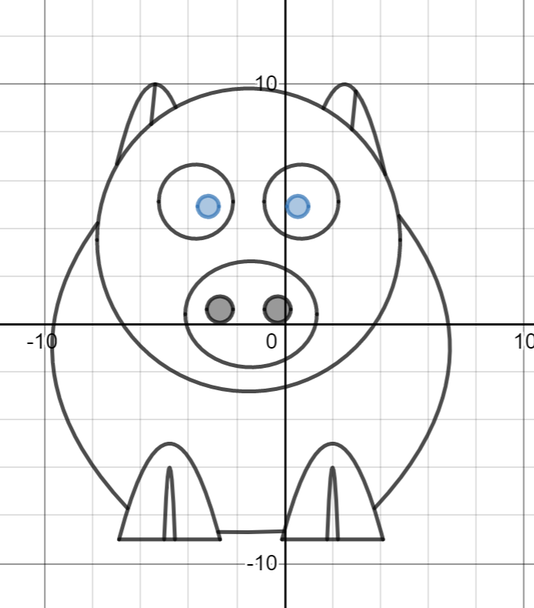 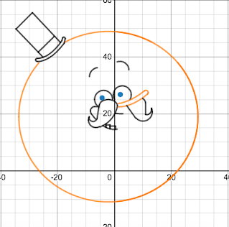

1 2 3

Sources:

1 <https://www.desmos.com/calculator/3khdqlk2o8>

2 <https://www.desmos.com/calculator/5qcrxjuvkv>

3 <https://sites.google.com/a/smmk12.org/mrmauck/desmos-art-galery-2018-2019>

**Task 2: [15 marks]**

Consider the picture below.

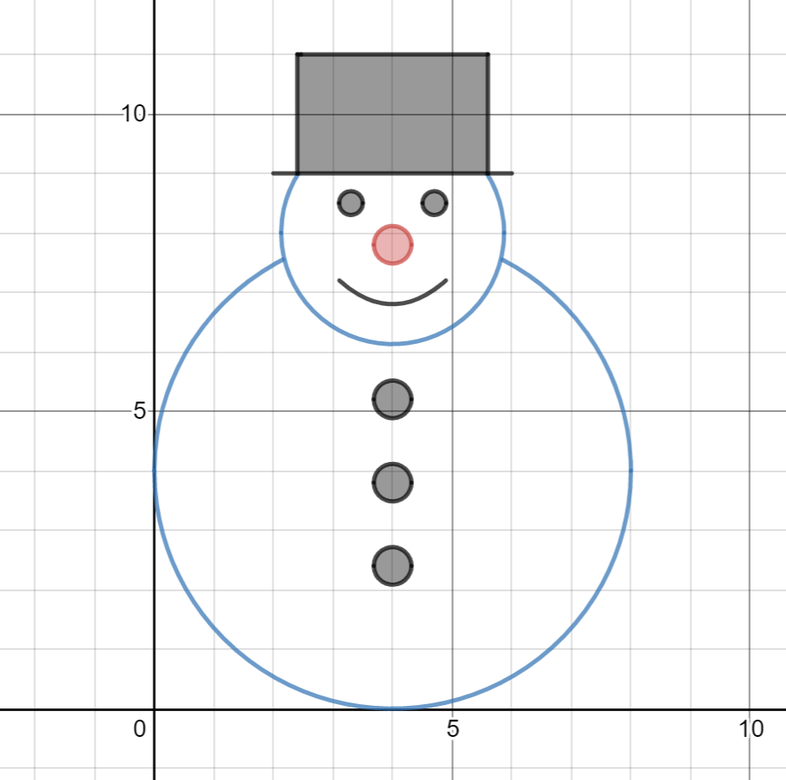

Produce a report of the equations used to create the picture and how they may have been translated.

**END OF ASSESSMENT**